30-Minute Student Task-GEN AI MASTERY
Build Your Own Rule-Based Python Chatbot
Assessment Submission

Student Name | SEELAM LAKSHMI ROHITH REDDY
Registration Number | 99230040756____________
Mail | rohithreddy2911@gmail.com
Dept | CSE(4th Year)

1. Objective
To build a simple rule-based conversational chatbot in Python that continuously interacts with the user, recognizes different messages, provides appropriate responses, and allows the user to exit the conversation.

2. Requirements Implemented
- Ask the user's name before the main conversation.
- Use while True: to keep the conversation running.
- Use input() to receive messages.
- Clean input using .lower().strip().
- Recognize greetings such as hello and hi.
- Answer at least three different questions or topics.
- Use if / elif / else for decision making.
- Use break to exit when the user types bye or exit.
- Use the user's name in a response.
- Provide a useful response for unknown messages using else.
- Use the in operator so variations such as hello bot can trigger a greeting.

3. Chatbot Flow
INPUT → PROCESS → RESPOND → REPEAT → EXIT

4. Working of the Chatbot
Name Input: The chatbot first asks the user for their name and stores it in the name variable.
Message Input: The chatbot repeatedly asks the user for a message inside a while True loop.
Input Cleaning: The message is cleaned using .lower().strip() so uppercase letters and extra spaces do not prevent matching.
Decision Making: The chatbot uses if, elif, and else conditions to decide which response to provide.
Flexible Greeting: The in operator allows messages containing the word hello, such as hello bot or hey hello, to trigger the greeting.
Exit: When the user enters bye or exit, the chatbot prints a goodbye message and uses break to end the loop.
Unknown Input: If none of the known conditions match, else provides a response saying that the chatbot does not understand the message yet.

5. Python Source Code
name = input("What is your name? ")
print("Hello", name)
print("Welcome to my chatbot!")
while True:
message = input("You: ").lower().strip()
if "hello" in message:
print("Chatbot: Hello! Nice to meet you.")
elif message == "hi":
print("Chatbot: Hi! How can I help you?")
elif message == "what is python":
print("Chatbot: Python is a programming language.")
elif message == "how are you":
print("Chatbot: I'm doing great! Thanks for asking.")
elif message == "what can you do":
print("Chatbot: I can answer simple questions and have a basic conversation.")
elif message == "bye" or message == "exit":
print("Chatbot: Goodbye", name, "!")
break
else:
print("Chatbot: Sorry, I don't understand that yet.")

6. Testing and Results
Test Input | Expected Response | Result
hello | Hello! Nice to meet you. | Passed
HELLO | Hello! Nice to meet you. | Passed
hi | Hi! How can I help you? | Passed
hello bot | Hello! Nice to meet you. | Passed
what is python | Python is a programming language. | Passed
how are you | I'm doing great! Thanks for asking. | Passed
what can you do | I can answer simple questions and have a basic conversation. | Passed
unknown message | Sorry, I don't understand that yet. | Passed
bye / exit | Goodbye <user name> ! and the program stops. | Passed

7. Demonstration Example
What is your name? Praveen
Hello Praveen
Welcome to my chatbot!
You: hello
Chatbot: Hello! Nice to meet you.
You: hello bot
Chatbot: Hello! Nice to meet you.
You: what is python
Chatbot: Python is a programming language.
You: how are you
Chatbot: I'm doing great! Thanks for asking.
You: what is the weather
Chatbot: Sorry, I don't understand that yet.
You: bye
Chatbot: Goodbye Praveen !

8. Execution Screenshots
Insert screenshots below showing the chatbot running successfully. Recommended screenshots: name input, greeting, question response, unknown-message response, and bye/exit.
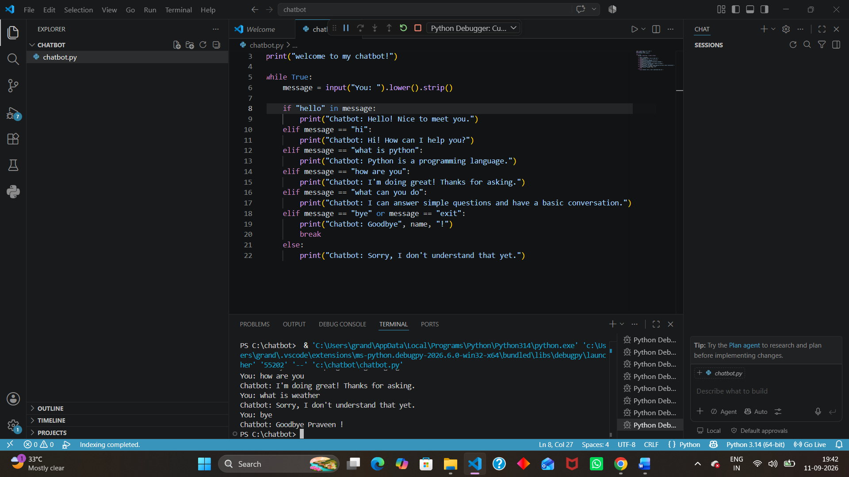
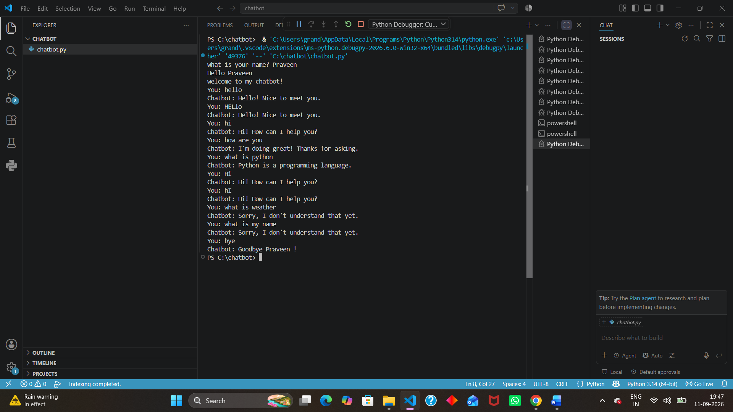

9. Conclusion
The rule-based Python chatbot was successfully implemented and tested. It accepts user input continuously, cleans the input, recognizes greetings and multiple topics, handles unknown messages, uses the user's name, and exits when the user enters bye or exit.

10. Final Assessment Checklist
- ✓ Chatbot asks for the user's name.
- ✓ Chatbot runs continuously using while True.
- ✓ User input is cleaned using .lower().strip().
- ✓ At least two greetings are recognized.
- ✓ At least three questions/topics are answered.
- ✓ if / elif / else decision making is used.
- ✓ bye and exit stop the chatbot using break.
- ✓ The user's name is included in a response.
- ✓ Unknown messages receive a useful response.
- ✓ The in operator is used for flexible greeting recognition.
- ✓ The chatbot was tested with the required inputs.

